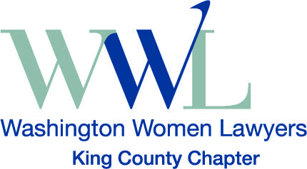
King County Washington Women Lawyers
Natalie Moore, Scholarship Committee Chair
kcwwlscholarship@gmail.com
2019 King County Support for Solo and
Small Firm Attorneys Grants
Sponsored by Washington Women Lawyers, King County Chapter
Grant Opportunity: The King County Chapter of Washington Women Lawyers (KCWWL) is pleased to provide a grant opportunity of up to $1,500 to recognize excellence in practice for new solo or small firm practitioners whose work benefits women directly or improves access to justice for women.
Eligibility criteria:
- Open to male and female attorneys who are members in good standing with the WSBA and have been in practice for five years or less at the time of application.
- Must be a solo practitioner or member of a small, private firm (2-5 attorneys) whose primary paid work benefits women directly, improves access to justice, or generates other community benefits for women.
- Must be a KCWWL member at the time of grant issuance.
Application materials:
- Resume, including contact information and WSBA license number.
- Essay (12-point font, double-spaced, no more than 3 pages) addressing how the candidate’s legal practice benefits women as clients or, more generally, demonstrates improvement in access to justice or the generation of community benefits targeted to women. Please also highlight any work done in King County.
- Brief statement of past or ongoing pro bono work.
Application process and deadline: Please submit application materials to Natalie Moore, KCWWL Scholarship Committee Chair, at kcwwlscholarship@gmail.com no later than October 14, 2019. Grant recipients will be notified in November 2019 and will be invited to attend the KCWWL Annual Holiday Celebration to be recognized as awardees.
Thank you for your interest in King County Washington Women Lawyers.

