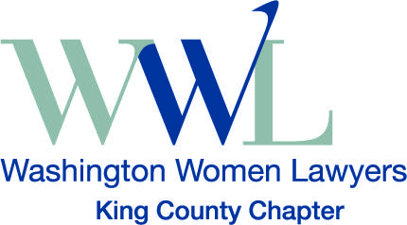
King County Washington Women Lawyers
Natalie Moore, Scholarship Committee Chair
kcwwlscholarship@gmail.com

2019 Seattle University School of Law Scholarship
Sponsored by Washington Women Lawyers, King County Chapter
Scholarship: The King County Chapter of Washington Women Lawyers (KCWWL) is pleased to provide a scholarship in the amount of $1,500.00 to one second year female law student at Seattle University School of Law. The scholarship is intended to promote individualism and courage within the profession and to support women who have the potential to make a significant contribution to the community and/or have demonstrated an ability to overcome significant obstacles, including financial obstacles, in their lives.
Requirements: The scholarship recipient must be a second-year female law student at Seattle University School of Law. The recipient must also be a student member of KCWWL (free for students). Throughout the 2019-2020 academic year, the recipient must commit ten hours of service to KCWWL. These hours can be fulfilled in a variety of ways, such as attending KCWWL social events, assisting at KCWWL’s Judicial Appreciation Luncheon, or attending KCWWL Board of Directors’ meetings.
Application Materials: Please submit a resume, first year law school transcript, and written statement (12-point font, double-spaced, no more than two pages). The written statement should address how the applicant intends to promote leadership of women within the legal profession. Explain how such leadership is intended to effect change regarding an issue the applicant believes women in the legal profession face today and/or will face in the future. Include examples from your past volunteer or work activities, if applicable. Please describe the steps you have taken so far towards achieving your goal.
Deadline: Please submit your application materials to Natalie Moore, KCWWL Scholarship Committee Chair, at kcwwlscholarship@gmail.com, no later than October 14, 2019. Scholarship recipients will be notified in November 2019 and will be invited to attend the KCWWL Annual Holiday Celebration to be recognized as awardees.
Thank you for your interest in King County Washington Women Lawyers.

